C8Proj1 Machine Learning

CLAM0905

January 14, 2020

#### This assignment is designed to perform prediction analysis on a large dataset, in order to predict the class of 20 test cases. Details can be found on the website, included below, and can be summed up by the following. Six participants were asked to perform one set of 10 repetitions of the Unilateral Dumbbell Biceps Curl in five different fashions: exactly according to the specification (Class A), throwing the elbows to the front (Class B), lifting the dumbbell only halfway (Class C), lowering the dumbbell only halfway (Class D), and throwing the hips to the front (Class E). My algorithm uses the “KNN: K nearest neighbor” approach to classify the existing 19,000+ cases into their appropriate class, where I will validate the efficiveness by comparing the predicted class to the actual class. From there, I will use my algorithm to classify the test cases into their predicted class, verifying the accuracy using the follow up quiz.

##### HAR website with background and more details: <http://web.archive.org/web/20161224072740/http:/groupware.les.inf.puc-rio.br/har>

#### Data exploration begins below

##### Read in training data:

Train <- read.csv("https://d396qusza40orc.cloudfront.net/predmachlearn/pml-training.csv")  
Trainset <- Train  
Trainsetsub <- subset(Train, select = -c(X,user_name,raw_timestamp_part_1,raw_timestamp_part_2,cvtd_timestamp,new_window,num_window))

##### Read in test data:

Test <- read.csv("https://d396qusza40orc.cloudfront.net/predmachlearn/pml-testing.csv")  
Testset <- Test  
Testsetsub <- subset(Testset, select = -c(X,user_name,raw_timestamp_part_1,raw_timestamp_part_2,cvtd_timestamp,new_window,num_window))

##### Summary of different classes in training data:

summary(Train$classe)

## A B C D E   
## 5580 3797 3422 3216 3607

##### Preprocessing and exploratory data analysis:

Trainbelt <- subset(Trainsetsub[,grepl("belt", names(Trainsetsub))])  
Trainbelt <- cbind(Trainbelt, userID = Trainsetsub$classe)  
#remove columns with little to no data  
Trainbelt <- Trainbelt[,c(1:4,30:39)]  
  
Trainarm <- subset(Trainsetsub[,grepl("_arm", names(Trainsetsub))])  
Trainarm <- cbind(Trainarm, userID = Trainsetsub$classe)  
#remove columns with little to no data  
Trainarm <- Trainarm[,c(1:4,15:23,39)]  
  
Traindumbell <- subset(Trainsetsub[,grepl("dumbbell", names(Trainsetsub))])  
Traindumbell <- cbind(Traindumbell, userID = Trainsetsub$classe)  
#remove columns with little to no data  
Traindumbell <- Traindumbell[,c(1:3,19,30:39)]  
  
Trainforearm <- subset(Trainsetsub[,grepl("forearm", names(Trainsetsub))])  
Trainforearm <- cbind(Trainforearm, userID = Trainsetsub$classe)  
#remove columns with little to no data  
Trainforearm <- Trainforearm[,c(1:3,19,30:39)]

#### Exploratory data analysis: The below graphs break up activity up by classe for the 4 different categories: trainbelt, trainarm, traindumbbell, trainforearm. This gives us an idea of what variables are correlated with the different classes. The graphs highlight the class breakdown by the following exercises, in order: roll, pitch, yaw, total accel, gyros belt x, gyros belt y, gyros belt z, accel belt x, accell belt y, accell belt z, magnet belt x, magnet belt y, and magnet belt z.

##### Train belt:

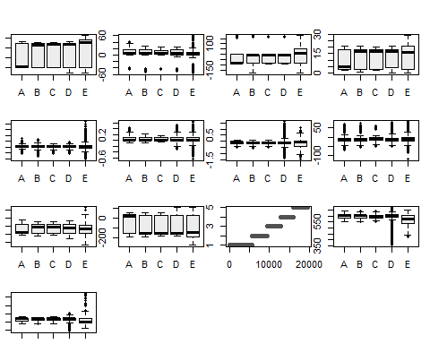

##### Train arm:

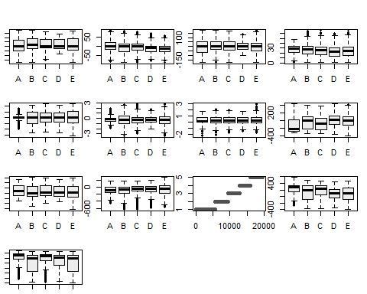

##### Train dumbbell:

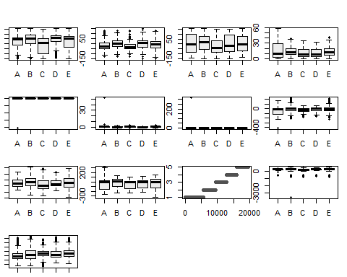

##### Train forearm:

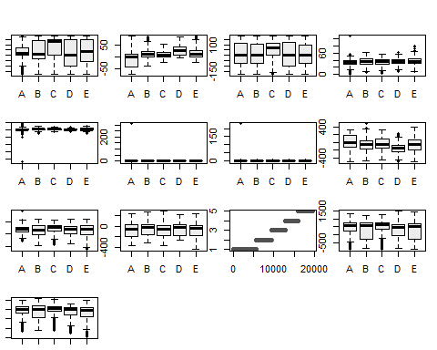

#### Prediction begins: We can now begin formatting and setting up the data for prediction analysis.

##### Begin cleanup for prediction

Trainsetsub1 <- Trainsetsub[,c(1:4,30:42,53:61,77:79,95,106:117,133,144:152,153)]  
  
Trainsetsub1$ID <- seq.int(nrow(Trainsetsub1))  
  
View(colnames(Trainsetsub1))

##### Generate a random number that is 90% of the total number of rows in dataset

set.seed(100)  
subset <- sample(1:nrow(Trainsetsub1), 0.9 * nrow(Trainsetsub1))

##### Create normalization function

normalize <-function(x) {(x -min(x))/(max(x)-min(x))}

##### Run nomalization on first 52 columns of dataset because they are the predictors, note this drops classe column and shows the normalized values between 0-1

Training1<- as.data.frame(lapply(Trainsetsub1[,c(1:52)], normalize))  
summary(Training1[1:5])

## roll_belt pitch_belt yaw_belt total_accel_belt  
## Min. :0.0000 Min. :0.0000 Min. :0.0000 Min. :0.0000   
## 1st Qu.:0.1572 1st Qu.:0.4958 1st Qu.:0.2554 1st Qu.:0.1034   
## Median :0.7433 Median :0.5261 Median :0.4652 Median :0.5862   
## Mean :0.4888 Mean :0.4832 Mean :0.4702 Mean :0.3901   
## 3rd Qu.:0.7957 3rd Qu.:0.6090 3rd Qu.:0.5373 3rd Qu.:0.6207   
## Max. :1.0000 Max. :1.0000 Max. :1.0000 Max. :1.0000   
## gyros_belt_x   
## Min. :0.0000   
## 1st Qu.:0.3098   
## Median :0.3282   
## Mean :0.3173   
## 3rd Qu.:0.3528   
## Max. :1.0000

##### Add classe back in

Training1$classe <- Trainsetsub1$classe

##### Extract training and test set

Training1_train <- Training1[subset,]   
Training1_test <- Training1[-subset,]

##### Extract 53rd column of train dataset because it will be used as ‘class’ argument in knn function.

Training1_target_category <- Training1_train[c(53)]  
Training1_train <- Training1_train[-c(53)]

##### Extract 53rd column of test dataset to measure the accuracy

Training1_test_category <- Training1_test[c(53)]  
Training1_test<- Training1_test[-c(53)]

install.packages("class")  
library(class)   
install.packages("gmodels")  
library(gmodels)

##### Format the datasets to data frames

Training1_train <- as.data.frame(Training1_train)  
Training1_test <- as.data.frame(Training1_test)  
Training1_target_category <- as.data.frame(Training1_target_category)

##### Run knn function using train, test and category datasets

knnpred <- knn(Training1_train,Training1_test,cl=Training1_target_category$classe,k=3)

##### Create a confusion matrix

confm <- table(knnpred,Training1_test_category$classe)  
confm

##   
## knnpred A B C D E  
## A 543 4 0 0 0  
## B 2 386 1 1 1  
## C 0 6 330 7 0  
## D 1 3 0 294 3  
## E 0 1 1 0 379

##### This function divides the correct predictions by total number of predictions to tell us how accurate the model is

accuracy <- function(x){sum(diag(x)/(sum(rowSums(x)))) * 100}  
accuracy(confm)

## [1] 98.42078

##### Validation Table

crosstable <- CrossTable(x = knnpred, y = Training1_test_category$classe, prop.chisq = FALSE)

## Total Observations in Table: 1963   
##   
## | Training1_test_category$classe   
## knnpred | A | B | C | D | E | Row Total |   
## -------------|-----------|-----------|-----------|-----------|-----------|-----------|  
## A | 543 | 4 | 0 | 0 | 0 | 547 |   
## | 0.993 | 0.007 | 0.000 | 0.000 | 0.000 | 0.279 |   
## | 0.995 | 0.010 | 0.000 | 0.000 | 0.000 | |   
## | 0.277 | 0.002 | 0.000 | 0.000 | 0.000 | |   
## -------------|-----------|-----------|-----------|-----------|-----------|-----------|  
## B | 2 | 386 | 1 | 1 | 1 | 391 |   
## | 0.005 | 0.987 | 0.003 | 0.003 | 0.003 | 0.199 |   
## | 0.004 | 0.965 | 0.003 | 0.003 | 0.003 | |   
## | 0.001 | 0.197 | 0.001 | 0.001 | 0.001 | |   
## -------------|-----------|-----------|-----------|-----------|-----------|-----------|  
## C | 0 | 6 | 330 | 7 | 0 | 343 |   
## | 0.000 | 0.017 | 0.962 | 0.020 | 0.000 | 0.175 |   
## | 0.000 | 0.015 | 0.994 | 0.023 | 0.000 | |   
## | 0.000 | 0.003 | 0.168 | 0.004 | 0.000 | |   
## -------------|-----------|-----------|-----------|-----------|-----------|-----------|  
## D | 1 | 3 | 0 | 294 | 3 | 301 |   
## | 0.003 | 0.010 | 0.000 | 0.977 | 0.010 | 0.153 |   
## | 0.002 | 0.007 | 0.000 | 0.974 | 0.008 | |   
## | 0.001 | 0.002 | 0.000 | 0.150 | 0.002 | |   
## -------------|-----------|-----------|-----------|-----------|-----------|-----------|  
## E | 0 | 1 | 1 | 0 | 379 | 381 |   
## | 0.000 | 0.003 | 0.003 | 0.000 | 0.995 | 0.194 |   
## | 0.000 | 0.002 | 0.003 | 0.000 | 0.990 | |   
## | 0.000 | 0.001 | 0.001 | 0.000 | 0.193 | |   
## -------------|-----------|-----------|-----------|-----------|-----------|-----------|  
## Column Total | 546 | 400 | 332 | 302 | 383 | 1963 |   
## | 0.278 | 0.204 | 0.169 | 0.154 | 0.195 | |   
## -------------|-----------|-----------|-----------|-----------|-----------|-----------|

##### Predicting test set data into appropriate classe, output suppressed to honor course code

#Subset same columns as test set  
Testset1 <- Testsetsub[,c(1:4,30:42,53:61,77:79,95,106:117,133,144:152,153)]  
#normalize  
Testset12<- as.data.frame(lapply(Testset1[,c(1:52)], normalize))  
#predict  
knntest <- knn(Training1_train,Testset12,cl=Training1_target_category$classe,k=3)

#### Conclusion: My knn algorithm was able to predict the class of the 20 test cases with 75% accuracy. The accuracy on the train dataset was 98%. This leads me to the conclusion that my knn algorithm was accurate, but overfit the train model and was not able to accurately predict on the test dataset to the same accuracy. More work needs to be done on my knn algorithm to be more accurate on test datasets, but it is a good start to learning and practicing machine learning techniques. Thank you for reading!